Mac Commands Guide

Gajam Goutham Kumar

09/06/2024

File Management Create empty file: **touch myfile.txt**

This creates an empty file named `myfile.txt`. Open file:

### open myfile.txt

This opens `myfile.txt` using the default application associated with text files. Output file contents:

### cat myfile.txt

This displays the contents of `myfile.txt`. See file contents page by page:

### less myfile.txt

This allows you to scroll through `myfile.txt` one page at a time. Output first 10 lines of file:

### head myfile.txt

This shows the first 10 lines of `myfile.txt`. Print first x lines of file:

### head -n 20 myfile.txt

This shows the first 20 lines of `myfile.txt`. Edit file in Nano:

### nano myfile.txt

This opens `myfile.txt` in the Nano text editor. Append text to file:

### echo "Additional text" >> myfile.txt

This adds "Additional text" to the end of `myfile.txt`.

Copy file:

### cp myfile.txt /path/to/destination/

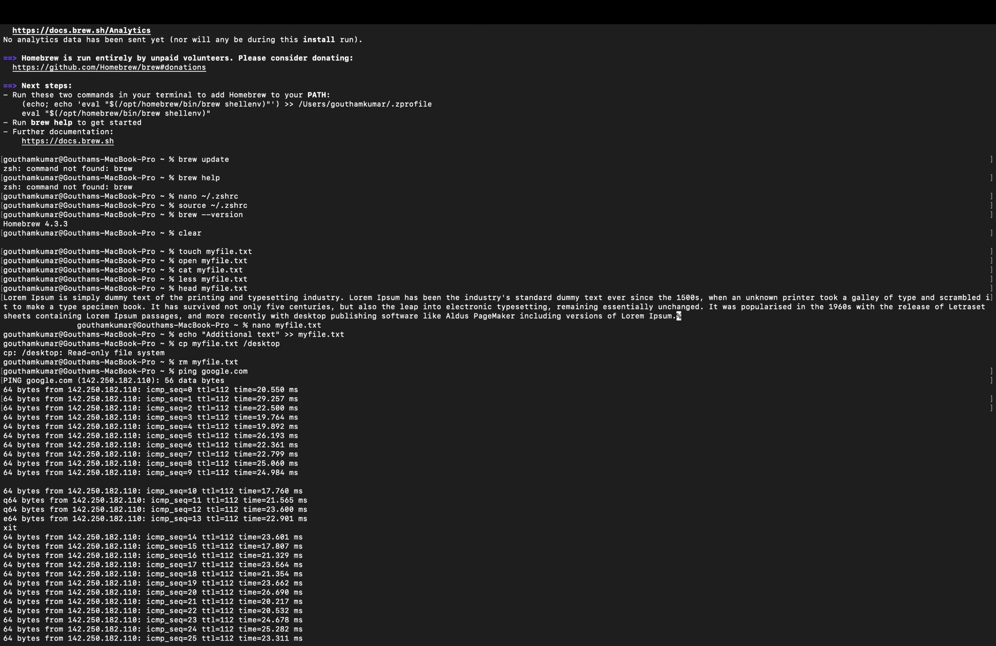

This copies `myfile.txt` to the specified destination directory.

Remove file:

### rm myfile.txt

This deletes `myfile.txt`

# Network

## Test remote connection:

### ping google.com

This sends packets to `google.com` to check the connection. View local network devices:

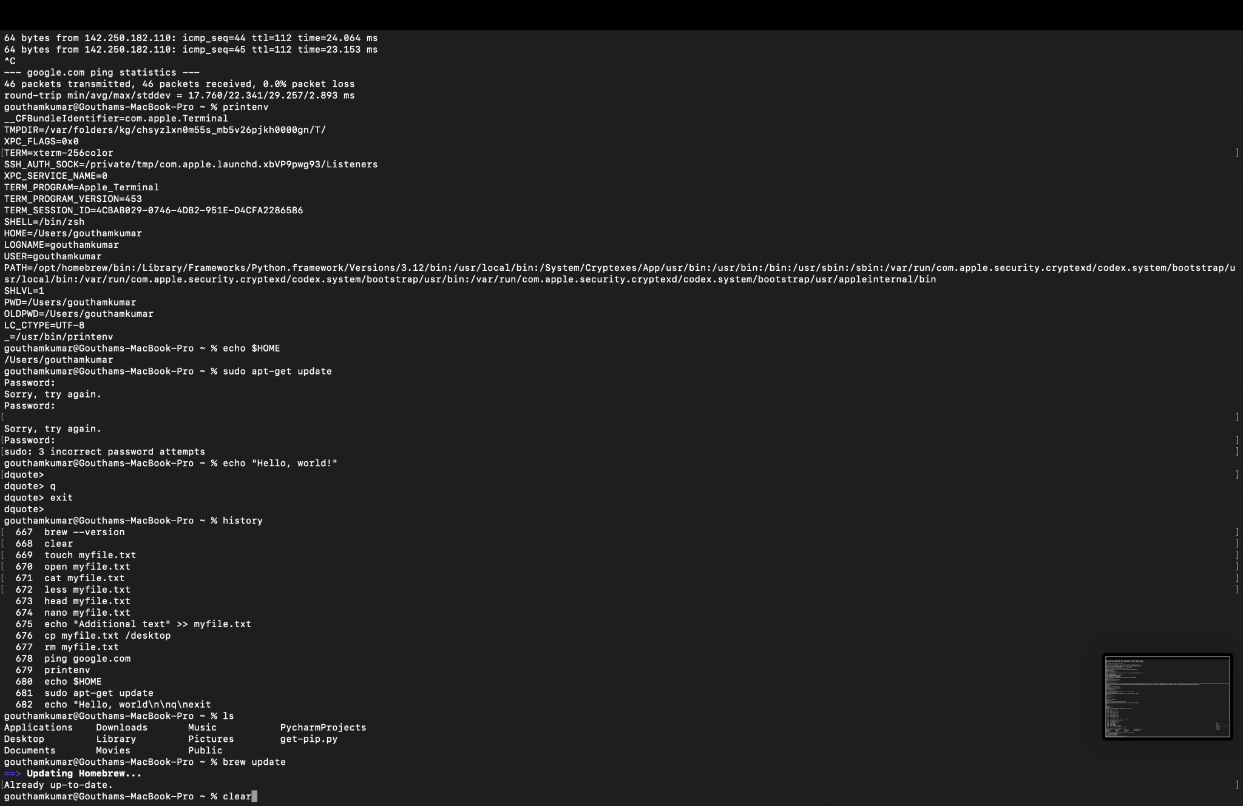

# System

## List all environment variables:

### printenv

This displays all environment variables. View variable value:

### echo $HOME

This prints the value of the `HOME` environment variable. Run commands as admin:

### sudo [command]

Prepend `sudo` to any command to run it with superuser privileges. For example: sudo apt-get update

Pipe command output:

### ls | grep ".txt"

This lists all `.txt` files by piping the output of `ls` to `grep`. Hide command output:

### [command] > /dev/null

For example:

ls > /dev/null

This runs the `ls` command but hides the output. Print text to output:

### echo "Hello, world!"

This prints "Hello, world!" to the terminal. List command history:

### history

This shows a list of previously run commands. Run previous command:

### !!

This runs the last executed command again. Get help for command:

### [command] --help

For example:

ls --help

This provides help information for the `ls` command. Read manual for command:

### man ls

This opens the manual page for the `ls` command.

# Homebrew Commands

## Update formulae:

### brew update

This updates Homebrew to the latest version and fetches the latest formulae. Upgrade formulae:

### brew upgrade

This upgrades all outdated Homebrew formulae. Install formula:

### brew install wget

This installs the `wget` formula. Uninstall formula:

### brew uninstall wget

This uninstalls the `wget` formula. List installed formulae:

### brew list --formula

This lists all installed Homebrew formulae.

# Shortcuts

## Open new window:

### Command - N

This opens a new Terminal window. Open new tab:

### Command - T

This opens a new tab in the Terminal. Close tab:

### Command - W

This closes the current tab. Make text bigger:

### Command - +

This increases the font size in the Terminal. Cut selection:

### Command - X

This cuts the selected text.

Copy selection:

### Command - C

This copies the selected text. Paste selection:

### Command - V

This pastes the copied text. Find text:

### Command - F

This opens the find bar to search for text. Select all:

### Command - A

This selects all text.

Full screen mode on/off:

### Control - Command - F

This toggles full-screen mode.